**Blatt 6**

Exercise 6.1

1.

a) The first used operation in Initialization, starting the algorithm with an empty stack, an I with all words from the input sentence and an empty spot for the current arc relation. The last operation is Termination (see task b). Between start and end of the algorithm, it uses PUSH-transitions and PULL-transitions. The PUSH-transitions are Shift what removes the first element from the remaining nodes to the stack and Right arc what takes the first element of the remaining nodes to the stack and copies the stack as on element to the current arc relation. The first PULL-transition Left arc also removes the first element of the remaining nodes to the stack but then removes the stack as one element to the current arc relation. The last transition Reduce just reduces the stack by its first element to avoid cycles in the output graph.

b) The algorithm terminates when it reaches the configuration (S, nil, A), what means variable values for the stack and the current arc relation (output at termination) but an empty I, so an empty list of remaining nodes to be integrated to the dependency graph. That means that all nodes (so all words from the input string) are integrated to the dependency graph.

c) Dependency graphs should be acyclic, connected and projective.

d)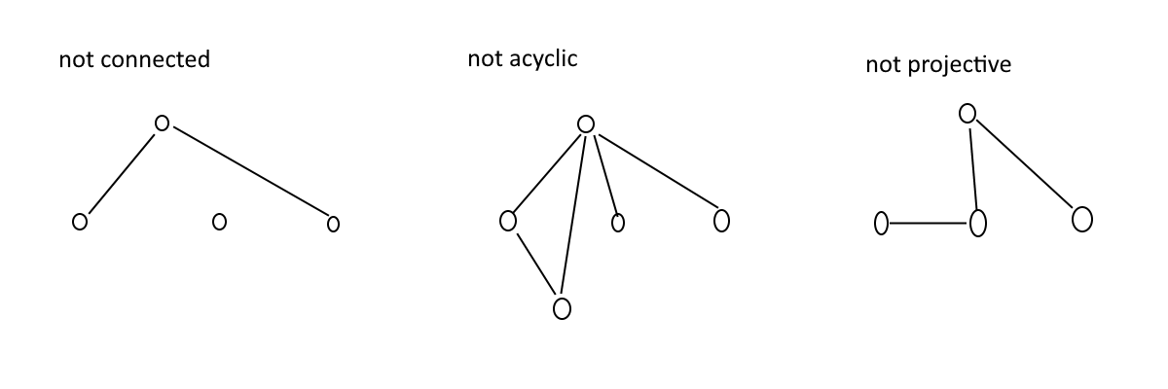

2.

Initialization:

(nil, Pa 60-talet malade han djärva tavlor som retade Nikita Chrusjtjov, ∅)

**S ->** (pa, 60-talet malade han djärva tavlor som retade Nikita Chrusjtjov, ∅)

**RA ->** (60-talet pa, malade han djärva tavlor som retade Nikita Chrusjtjov, {(pa, 60-talet)})

**R ->** (pa, malade han djärva tavlor som retade Nikita Chrusjtjov, {(pa, 60-talet)})

**LA ->** (nil, malade han djärva tavlor som retade Nikita Chrusjtjov, {(pa, 60-talet), (malade, pa})

**S ->** (malade, han djärva tavlor som retade Nikita Chrusjtjov, {(pa, 60-talet), (malade, pa})

**RA ->** (han malade, djärva tavlor som retade Nikita Chrusjtjov, {(pa, 60-talet), (malade, pa), (malade, han)})

**R ->** (malade, djärva tavlor som retade Nikita Chrusjtjov, {(pa, 60-talet), (malade, pa), (malade, han)})

**S ->** (djärva malade, tavlor som retade Nikita Chrusjtjov, {(pa, 60-talet), (malade, pa), (malade, han)})

**LA ->** (malade, tavlor som retade Nikita Chrusjtjov, {(pa, 60-talet), (malade, pa), (malade, han), (tavlor, djärva)})

**RA ->** (tavlor malade, som retade Nikita Chrusjtjov, {(pa, 60-talet), (malade, pa), (malade, han), (tavlor, djärva), (malade, tavlor)})

**LA ->** (malade, som retade Nikita Chrusjtjov, {(pa, 60-talet), (malade, pa), (malade, han), (tavlor, djärva), (malade, tavlor), (tavlor, som)})

**R ->** (nil, som retade Nikita Chrusjtjov, {(pa, 60-talet), (malade, pa), (malade, han), (tavlor, djärva), (malade, tavlor), (tavlor, som)})

**S ->** (som, retade Nikita Chrusjtjov, {(pa, 60-talet), (malade, pa), (malade, han), (tavlor, djärva), (malade, tavlor), (tavlor, som)})

**LA ->** (nil, retade Nikita Chrusjtjov, {(pa, 60-talet), (malade, pa), (malade, han), (tavlor, djärva), (malade, tavlor), (tavlor, som), (som, retade)})

**S ->** (retade, Nikita Chrusjtjov, {(pa, 60-talet), (malade, pa), (malade, han), (tavlor, djärva), (malade, tavlor), (tavlor, som), (som, retade)})

**RA ->** (Nikita retade, Chrusjtjov, {(pa, 60-talet), (malade, pa), (malade, han), (tavlor, djärva), (malade, tavlor), (tavlor, som), (som, retade), (retade, Nikita)})

**R ->** (retade, Chrusjtjov, {(pa, 60-talet), (malade, pa), (malade, han), (tavlor, djärva), (malade, tavlor), (tavlor, som), (som, retade), (retade, Nikita)})

**R ->** (Chrusjtjov retade, nil , {(pa, 60-talet), (malade, pa), (malade, han), (tavlor, djärva), (malade, tavlor), (tavlor, som), (som, retade), (retade, Nikita), (retade, Chrusjtjov)})

Termination; Output: {(pa, 60-talet), (malade, pa), (malade, han), (tavlor, djärva), (malade, tavlor), (tavlor, som), (som, retade), (retade, Nikita), (retade, Chrusjtjov)})